Highcliffe School Student Bulletin

Monday 21st – Friday 25th May 2007: Week A

Thought For The Week:
Peace is not the product of terror or fear.
Peace is not the silence of cemeteries.
Peace is not the silent result of violent repression.
Peace is the generous, tranquil contribution of all to the good of all.
Peace is dynamism. Peace is generosity.
It is right and it is duty.
Archbishop Oscar Romero

It is National Walk to School Week from Monday 21st May - 25th May.


You can all do your part to reduce both local air pollution and carbon dioxide by walking to school.
A few facts:
- Driving to school and back releases, on average, enough carbon dioxide to fill over 60 balloons! Not to mention all the other nasty pollutants such as carbon monoxide (the silent killer), nitrous oxides (mega nasty) and particulates (which clog up your breathing system)
- These stinky fumes make sufferers of asthma even worse and affect lung development
- Pollution levels inside the car can be three times worse than on the pavement. How horrid is that?!
- At 8.50am, 1 in 5 cars on the road is on the school run, and three quarters of cars taking children to school return straight back home again. That’s a lot of cars!
- Cars produce most pollution when they drive short distances, with a cold engine, in stop start conditions - does that sound like your drive to school in the morning?
Not nice is it? So get some exercise, enjoy the sunshine and breathe some clean air.
Walk or cycle to school when you can.

Remember to always be safe on the road - Wear a cycle helmet, walk in pairs and always be vigilant

Year 10 BERLIN TRIP 24th - 28th May: Please could all students who are going on the trip ensure that they have brought in their passports and EHIC's by Tuesday 22nd - to be taken to the Finance Office. They should attend lessons as normal periods 1 and 2, on Thursday, but ask permission to leave period 3 at 11.45am and meet in the covered way. Mrs Finch.

Reminder: Year 11 module 5 revision has changed to Mondays after school.

Arrival of our Dutch friends: On the evening of Monday 21st May 15th students and 2 staff from our partner Dutch school in Zandaam will be arriving in England as the second leg of the annual exchange.

This is the second year that the exchange has run and I am sure that all of the year 10 students involved will agree that it has been a brilliant experience. The Dutch students may be in some year 10 lessons. Please make them welcome.!

MUSIC NOTICES
For those who want to be involved in performing in the summer concert:

Harmonious Funk Jazz band - Tuesday 3:30pm – 5.00pm
Shout - Wednesday 3:30pm - 4:30pm (Years 7 - 9)
Vocalis - Thursday 3:30pm - 4:30pm (Years 10 - 13)
Guitar Club - Friday lunchtimes 1.40pm - 2.10pm

PE Notices
Results:

Year 12 rounders v Shaftesbury - won
Year 9 rounders v Sturminster Newton - lost (by 1 rounder!)
Year 10 cricket v Ringwood - won

P.E. FIXTURES/PRACTICES

21st May – 25th May 2007

 | LUNCHTIME | AFTER SCHOOL
Monday 21st |  | Year 8 rounders v Gillingham (H)
Tuesday 22nd | Year 10 cricket | Years 7 & 8 rounders practice  Year 8 cricket v Shaftesbury (A)  Year 9 rounders v Ferndown (A)
Wednesday 23rd | Year 7 cricket | Athletics club  Years 7 & 10  rounders v Avonbourne (H)
Thursday 24th | Year 8 cricket | TOWN SPORTS @ Kings Park  Years 8 & 9  rounders v Parkstone Grammar (H)
Friday 25th | Year 9 cricket


BRAIN TEASER

This weeks Brainteaser:

Each child in a family has at least 2 brothers and 4 sisters. What is the smallest number of children the family might have?

Answers to be submitted in the brainteaser box in Ma6 before Friday 25th May. Good luck!

BUILD YOU VOCABULARY
Spelling methods practice

What would be a good way to remember the following spellings?
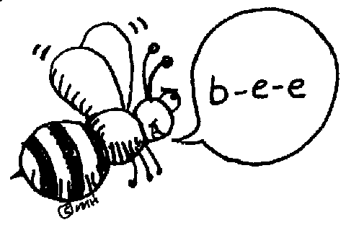
1. parallel

2. Parliament

3. attendance

Some suggestions for remembering them:

1. The two "l" s run parallel. They are like a railway track going through the middle of the word.

2. Students normally miss out the "i". “I vote for a member of Parliament.”
Say the syallables in an exaggerated tone so the "i" sound can be heard: PAR-LI-A-MENT

3. Attendance - Is it "e" or "a" in the final syallble? It's "a" because "At ten, there is a "dance".

AMAZING ECO FACT
Each year in Britain, we throw away 28 million tonnes of rubbish from our homes. This weighs the same as three and a half million double decker buses! A queue of buses that long would go around the world one and a half times!

So REDUCE, REUSE, RECYCLE!

